**What Is Cloud Computing?**

**Cloud Computing** means storing and accessing the data and programs on remote servers that are hosted on the internet instead of the computer’s hard drive or local server. Cloud computing is also referred to as Internet-based computing, it is a technology where the resource is provided as a service through the Internet to the user. The data that is stored can be files, images, documents, or any other storable document.

The following are some of the Operations that can be performed with Cloud Computing

* Storage, backup, and recovery of data
* Delivery of software on demand
* Development of new applications and services
* Streaming videos and audio

**Understanding How Cloud Computing Works?**

Cloud computing helps users in easily accessing computing resources like storage, and processing over internet rather than local hardwares. Here we discussing how it works in nutshell:

* **Infrastructure:**Cloud computing depends on remote network servers hosted on internet for store, manage, and process the data.
* **On-Demand Acess:** Users can access cloud services and resources based on-demand they can scale up or down the without having to invest for physical hardware.
* **Types of Services:**Cloud computing offers various benefits such as cost saving, scalability, reliability and acessibility it reduces capital expenditures, improves efficiency.

**Origins Of Cloud Computing**

Mainframe computing in the 1950s and the internet explosion in the 1990s came together to give rise to cloud computing. Since businesses like Amazon, Google, and Salesforce started providing web-based services in the early 2000s. The term “cloud computing” has gained popularity. Scalability, adaptability, and cost-effectiveness are to be facilitated by the concept’s on-demand internet-based access to computational resources.

These days, cloud computing is pervasive, driving a wide range of services across markets and transforming the processing, storage, and retrieval of data

**What is Virtualization In Cloud Computing?**

[Virtualization](https://www.geeksforgeeks.org/virtualization-cloud-computing-types/) is the software technology that helps in providing the logical isolation of physical resources. Creating logical isolation of physical resources such as RAM, CPU, and Storage.. over the cloud is known as Virtualization in Cloud Computing. In simple we can say creating [types of Virtual Instances](https://www.geeksforgeeks.org/types-of-virtual-machines/) of computing resources over the cloud. It provides better management and utilization of hardware resources with logical isolation making the applications independent of others. It facilitates streamlining the resource allocation and enhancing scalability for multiple virtual computers within a single physical source offering cost-effectiveness and better optimization of resources.

To know about this refer this Article – [Virtualization in Cloud Computing and Types](https://www.geeksforgeeks.org/virtualization-cloud-computing-types/)

Chatgpt :-

**Virtualization**: It creates virtual versions of physical computing resources, enabling cloud services to be more efficient and flexible.

Virtualization plays a crucial role in cloud computing by enabling the efficient use and management of computing resources.

**Key Role of Virtualization in Cloud Computing:**

1. **Resource Utilization**: Virtualization allows cloud providers to create multiple virtual machines (VMs) on a single physical server. This means that instead of having one physical machine dedicated to a single task, multiple VMs can share the same physical resources (like CPU, memory, and storage), maximizing resource utilization.
2. **Isolation and Security**: Each virtual machine operates independently of others, providing isolation. Even if multiple VMs run on the same physical server, they cannot directly interfere with one another, which enhances security and stability in the cloud environment.
3. **Scalability and Flexibility**: Virtualization allows cloud providers to quickly spin up or shut down VMs based on demand. This flexibility is a key feature of cloud computing, allowing businesses to scale resources up or down efficiently without having to buy physical hardware.
4. **Cost Efficiency**: Virtualization reduces the need for physical hardware. Multiple virtual instances can run on the same physical server, lowering the cost of hardware procurement and maintenance. This also helps with efficient power usage and space savings.
5. **Disaster Recovery**: Virtual machines can easily be backed up and moved between physical servers, which facilitates disaster recovery. In case of hardware failure, virtual instances can be restored quickly, minimizing downtime.
6. **Load Balancing**: Virtualization helps distribute workloads across multiple virtual machines, improving system performance and ensuring that no single VM becomes a bottleneck. This is particularly important in cloud computing where resources need to be dynamically allocated based on usage.

**How it Works in Cloud Computing:**

* **Hypervisor**: At the heart of virtualization is the hypervisor (or Virtual Machine Monitor). The hypervisor is software that sits between the hardware and the virtual machines, managing the physical resources and ensuring each VM gets the necessary resources.
  + **Type 1 Hypervisors** (Bare-Metal): Run directly on the hardware (e.g., VMware ESXi, Microsoft Hyper-V).
  + **Type 2 Hypervisors**: Run on top of an operating system (e.g., Oracle VirtualBox, VMware Workstation).

**In Cloud Services:**

Cloud providers like AWS, Azure, and Google Cloud use virtualization to offer Infrastructure as a Service (IaaS) to users, allowing them to rent virtualized computing resources instead of having to manage physical servers.

In summary, virtualization is the backbone of cloud computing, making it possible to offer scalable, flexible, and cost-efficient services to users.

Top of Form

Bottom of Form

**Architecture Of Cloud Computing**

[Cloud computing architecture](https://www.geeksforgeeks.org/architecture-of-cloud-computing/) refers to the components and sub-components required for cloud computing. These components typically refer to:

1. Front end ( Fat client, Thin client)
2. Back-end platforms ( Servers, Storage )
3. Cloud-based delivery and a network ( Internet, Intranet, Intercloud )

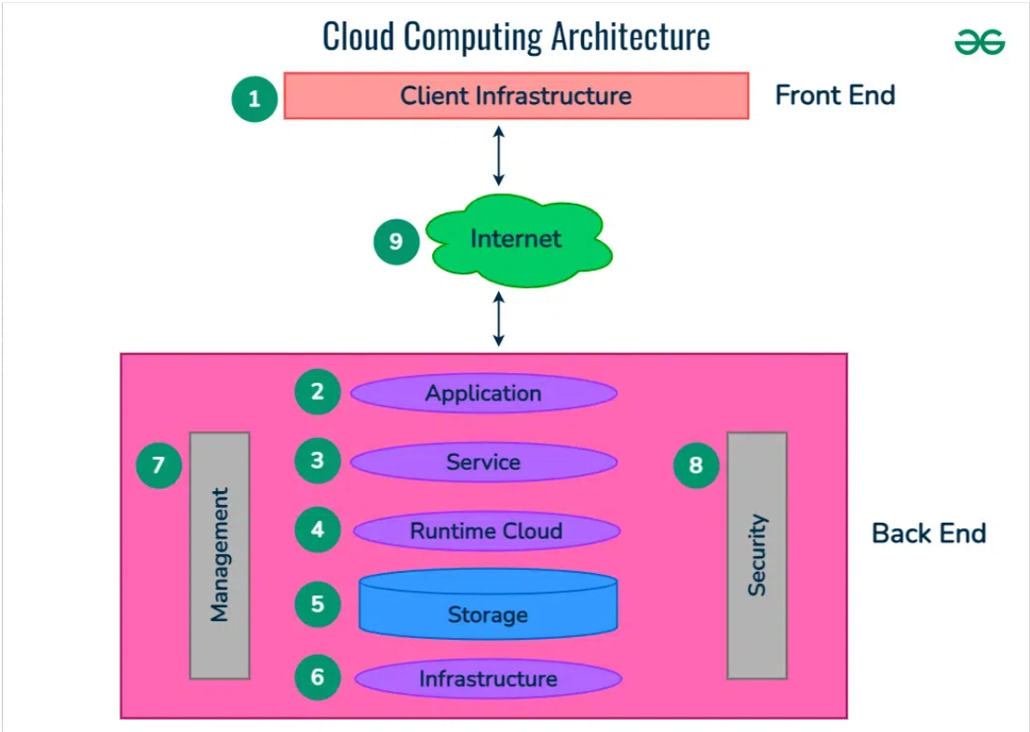

**VPC**

A Virtual Private Cloud (VPC) is a fundamental concept in cloud computing, especially in platforms like AWS, Google Cloud, and Microsoft Azure. It allows you to create an isolated network within a public cloud where you can manage and deploy your cloud resources securely. Let’s break down the key concepts and features of a VPC:

1. VPC Basics

* Definition: A VPC is essentially a logically isolated section of a cloud provider’s network where you can launch resources like virtual machines, databases, and services.
* Isolation: Though VPCs exist within a public cloud, they provide isolation as if they were a private network, ensuring security and privacy.
* Customization: You can customize your VPC’s IP address range, create subnets, configure route tables, and setup gateways.

2. Subnets

* Subnets are subdivisions within a VPC that allow you to segment your network. Each subnet resides within a specific availability zone (AZ) and can be either public or private.
  + Public Subnet: Connected to the internet via an Internet Gateway (IGW), allowing public access.
  + Private Subnet: Does not have direct internet access, and is often used for databases, backend systems, etc.

3. IP Addressing

* IPv4 CIDR Block: You must assign a Classless Inter-Domain Routing (CIDR) block (IP range) when creating a VPC. This defines the range of IP addresses your VPC can use.
  + Example: 10.0.0.0/16 allows for 65,536 IP addresses.
* IPv6 Support: VPCs can also support IPv6 addressing for modern connectivity needs.

4. Route Tables

* A Route Table controls the network traffic within your VPC by defining the routing rules for traffic going to or from your subnets.
  + Local Routes: Automatically created to allow communication within the VPC.
  + Custom Routes: Can be created to direct traffic to other resources (like Internet Gateway or Virtual Private Gateway).

5. Gateways

* Internet Gateway (IGW): Allows public traffic to access resources within the VPC. It's required for public subnets to communicate with the internet.
* NAT Gateway: Used to allow private subnets to initiate outbound internet connections without exposing the resources to inbound traffic.
* Virtual Private Gateway (VGW): Used to connect your VPC to an on-premises network through a VPN connection.

6. Network Access Control Lists (NACLs)

* NACLs are optional security layers that operate at the subnet level to control inbound and outbound traffic. They work as stateless firewalls.
  + Stateless: This means that each traffic rule (inbound and outbound) must be explicitly set.

7. Security Groups

* Security Groups are the primary security mechanism in a VPC. They act as virtual firewalls controlling inbound and outbound traffic at the instance level.
  + Stateful: If you allow traffic in one direction (e.g., inbound), the return traffic is automatically allowed.

8. Elastic IP (EIP)

* An Elastic IP is a static public IPv4 address that can be assigned to an instance in a VPC, providing consistent internet connectivity.

9. Peering Connections

* VPC Peering allows two VPCs to connect and route traffic between them using private IP addresses, enabling communication between resources in different VPCs.
  + Peering can be done within the same account or across different AWS accounts.

10. VPN & Direct Connect

* VPN: You can set up a VPN connection between your on-premises network and the cloud VPC using a Virtual Private Gateway, enabling secure communication.
* AWS Direct Connect: Provides a dedicated, high-speed, low-latency connection between your data center and AWS VPC, bypassing the internet.

11. Flow Logs

* VPC Flow Logs capture detailed information about the IP traffic to and from network interfaces within the VPC. This data can be helpful for troubleshooting, security analysis, or compliance.

12. VPC Endpoints

* VPC Endpoints allow you to privately connect your VPC to supported AWS services without needing an internet gateway or NAT, thus securing traffic within AWS’s network.
  + Gateway Endpoint: For services like S3 and DynamoDB.
  + Interface Endpoint: Provides a network interface to connect to other services via private IP.

13. Availability Zones and Regions

* Availability Zones (AZs) are isolated data centers within a region. When you create a VPC, your subnets are distributed across these AZs to ensure fault tolerance.
* Regions are the broader geographical locations (like US-East-1, EU-West-2) where multiple AZs reside.

Example of a Typical VPC Setup:

* VPC CIDR Block: 10.0.0.0/16
* Subnets:
  + Public Subnet 1: 10.0.1.0/24 (with Internet Gateway)
  + Private Subnet 2: 10.0.2.0/24 (with NAT Gateway for internet access)
* Route Table:
  + Public subnet route: Routes traffic to IGW.
  + Private subnet route: Routes traffic to NAT Gateway.
* Security Groups:
  + Web server security group: Allows inbound HTTP/HTTPS traffic on port 80/443.
  + Database security group: Only allows inbound traffic from web servers.

Key Benefits of Using a VPC:

1. Security and Isolation: You have full control over your networking environment, including traffic routing, IP ranges, and security.
2. Scalability: VPCs can scale with your cloud resources, allowing you to add or remove subnets, instances, and other resources easily.
3. Customizability: You can fine-tune networking to meet your application needs.
4. Interconnectivity: Through peering, VPNs, and gateways, you can connect VPCs to each other and to your on-premises networks.

Let me know if you'd like to dive deeper into any specific aspect of VPCs!